1. Import iGoWeb.war file to Eclipse
2. Run it on Glass Fish ( Tested using Glass Fish 4 and Jdk 1.8.0_20 )
3. Run the Project and Run it on server “GlassFish”
4. Once it is deployed check the deployed applications

(or)

1. Directly Deploy war file on GlassFish

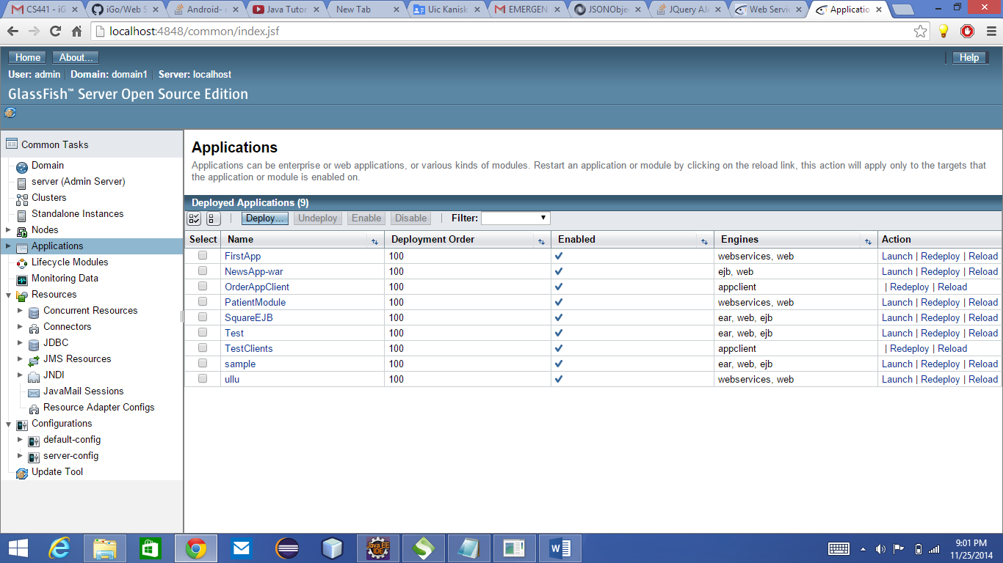

1. Click on “FirstApp”

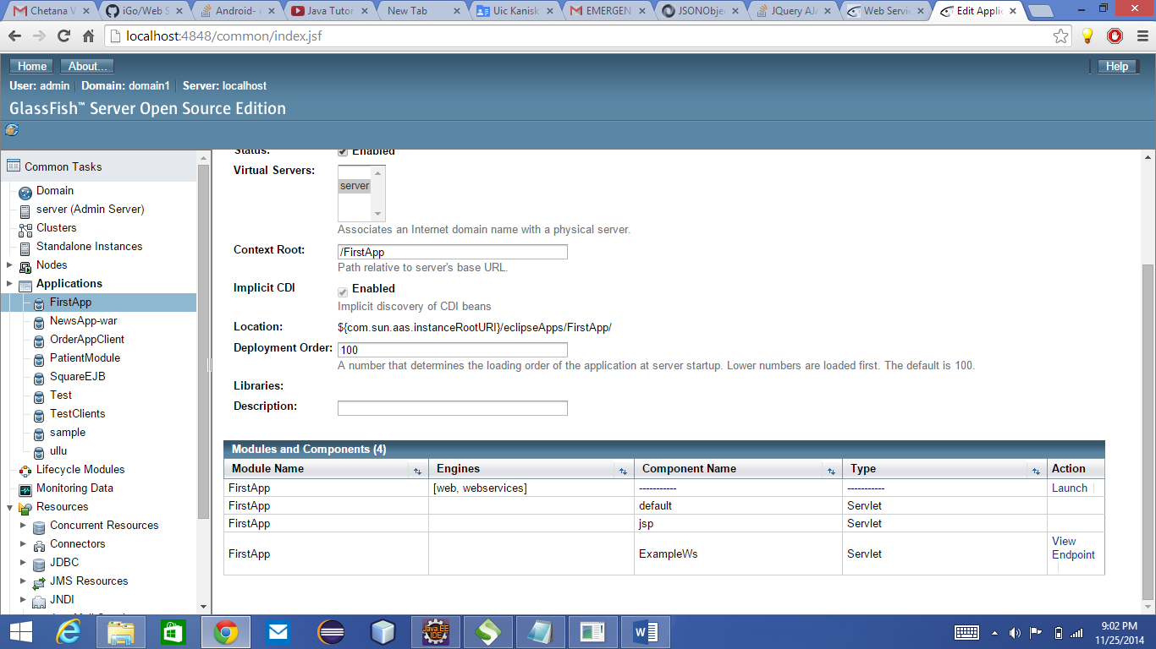

1. Click on “View Endpoint”

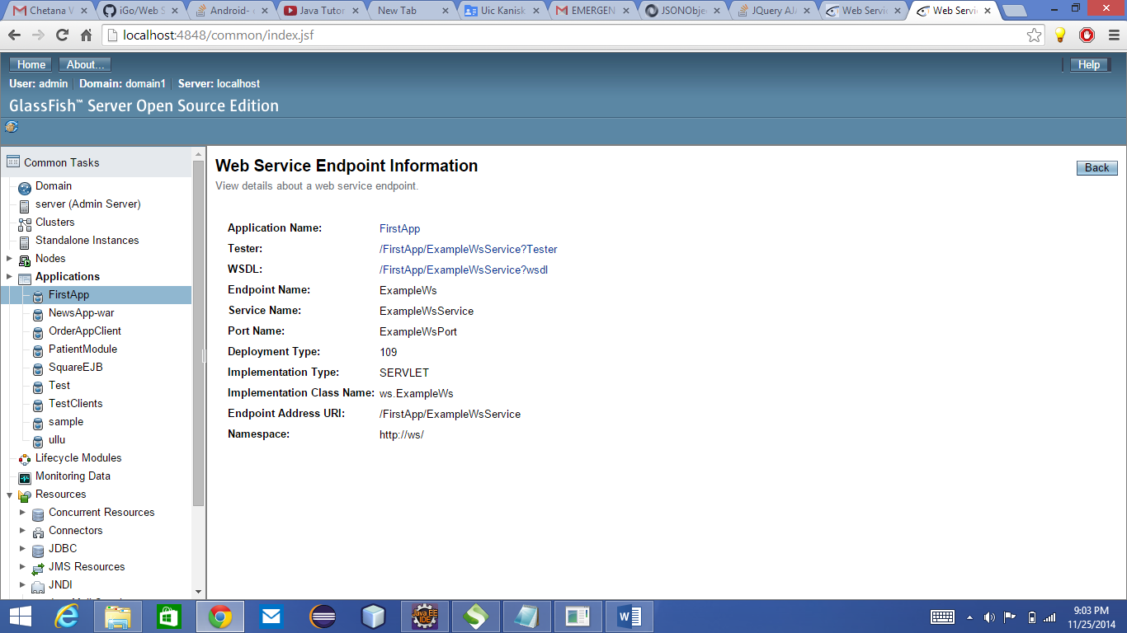

1. Click on “WDSL” Link

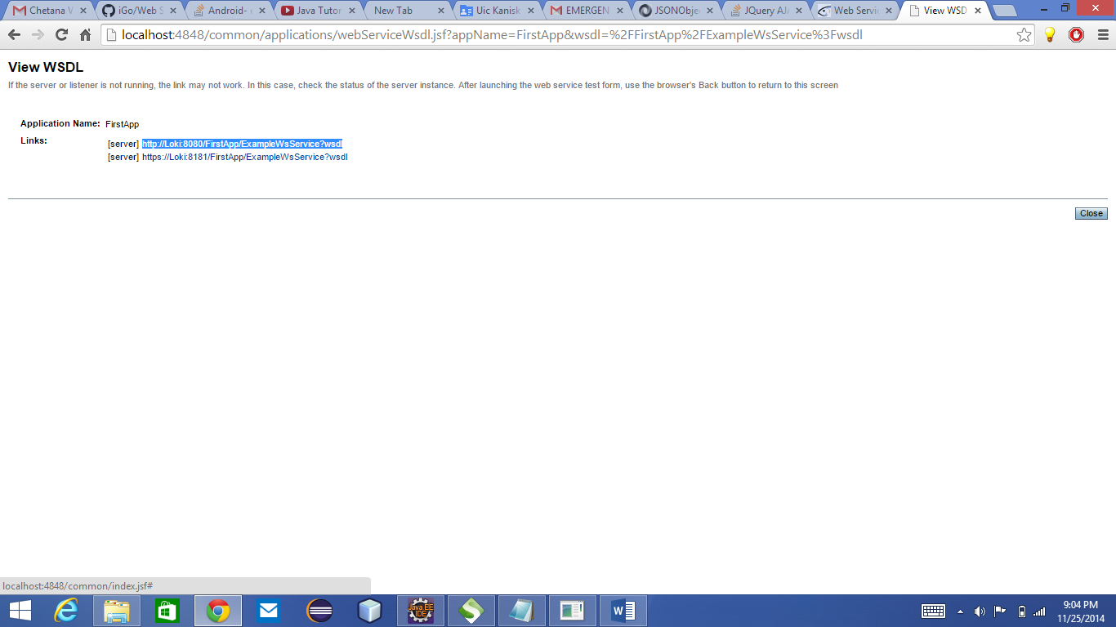

1. Copy the Link: [http://Loki:8080/FirstApp/ExampleWsService?wsdl](http://loki:8080/FirstApp/ExampleWsService?wsdl)

**Testing Steps:**

Testing the deployed using SOAP UI: (Tested the web service now using SOAP UI, download free soap ui from: <http://sourceforge.net/projects/soapui/files/> )

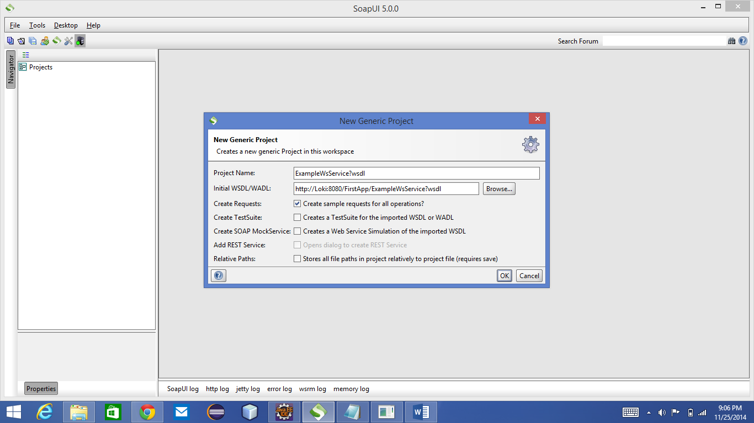

Navigate to Request 1 and click on “Request 1”

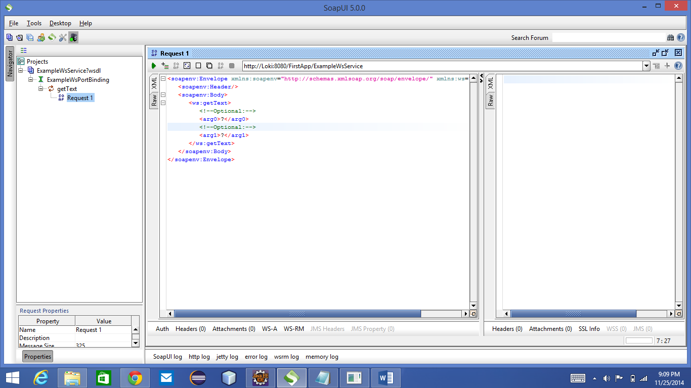

Give parameters <arg0>W Taylor St</arg0> & <arg1>Chicago, IL<arg1>

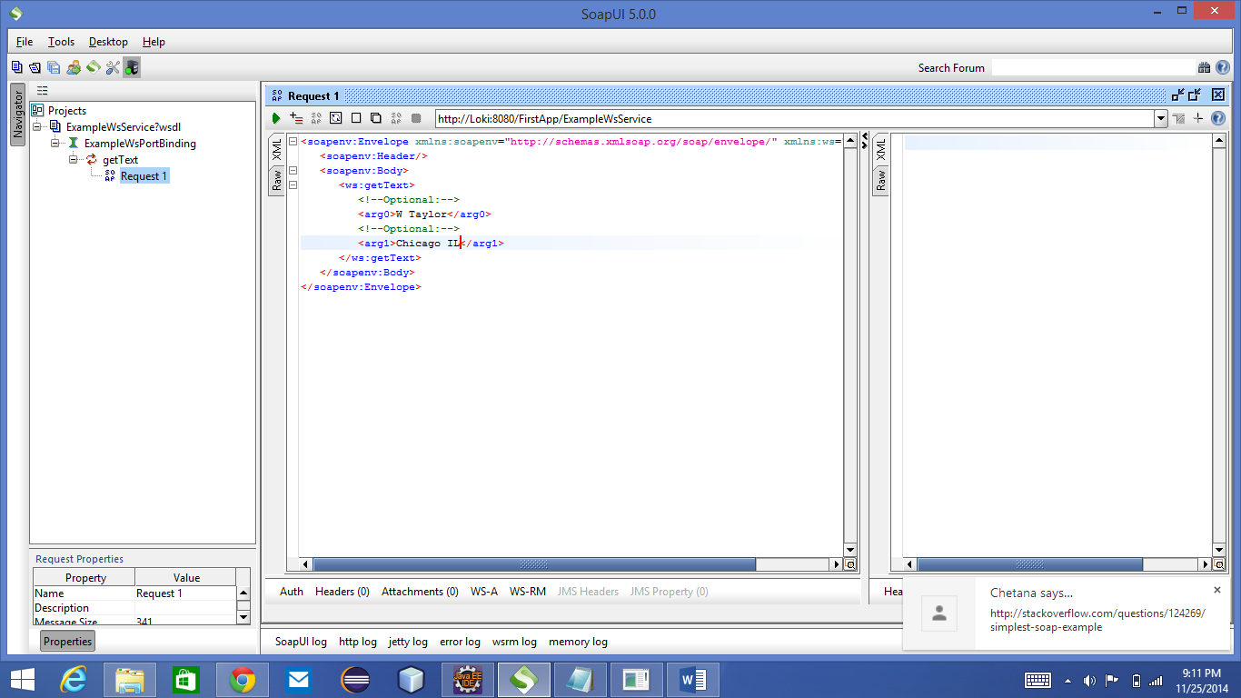

Click on Green 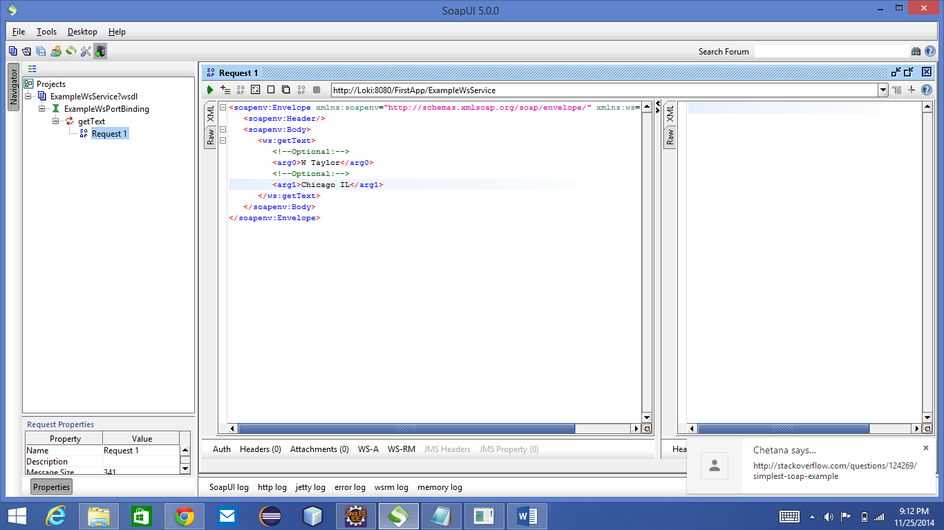 , to submit the request to the JAX-WS and the response will be returned.

